Ózdi Szc Bródy Imre technikum
Wifi 6
Ózd 2025.11.04 Created by :Máté Székely

Tartalomjegyzék
1. Key features of Wi-Fi 6 technology 3
2. Comparison with previous standards 3
3.Benefits and application areas 4
4. Summary 4
5. References 4


The internet has become an integral part of our daily lives: we need a constant online connection at home, at school and at work. The development of wireless networks (Wi-Fi) plays a key role in this process. In recent years, Wi-Fi 6, also known as 802.11ax, has been the latest milestone in this area. This technology not only offers faster data transmission, but also more efficiently handles many devices at the same time and provides a more stable connection even in crowded environments. Wi-Fi 6 is designed for the needs of the modern digital society, where an increasing number of smart devices operate on the same network.

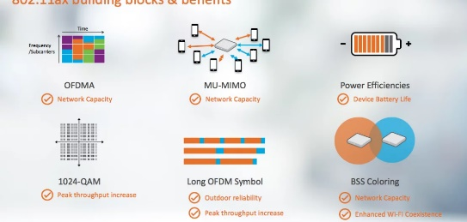
1. Key features of Wi-Fi 6 technology
Wi-Fi 6 aims to achieve higher speeds and better efficiency, especially for large numbers of users. Some of the key features of the technology are:
• OFDMA (Orthogonal Frequency Division Multiple Access): This technology allows multiple devices to communicate on a single data channel at the same time. This reduces latency and makes data traffic management more efficient.
• MU-MIMO (Multi-User, Multiple Input Multiple Output): Already used in Wi-Fi 5, Wi-Fi 6 has improved it. Now, multiple devices can communicate simultaneously not only during downloads, but also during uploads.
• TWT (Target Wake Time): This new feature is designed to save energy. Devices can remain in “sleep” mode until data traffic is needed, so that, for example, the battery of smart home devices lasts much longer.
• 1024-QAM modulation: Thanks to the higher modulation density, data transfer speeds increase - up to 9.6 Gb/s are possible under ideal conditions

2. Comparison with previous standards
As Wi-Fi technology has evolved, several standards have followed one another: Wi-Fi 4 (802.11n),
Wi-Fi 5 (802.11ac) and now Wi-Fi 6 (802.11ax).
Feature Wi-Fi 4 Wi-Fi 5 Wi-Fi 6
Maximum speed 600 Mb/s 3.5 Gb/s 9.6 Gb/s
Frequency Band 2.4 GHz 5 GHz 2.4 GHz and 5 GHz
Device Management Limited Better, but not yet optimal Simultaneous support for multiple devices
Energy Efficiency Low Medium High (due to TWT technology)
One of the most important advantages of Wi-Fi 6 is that it provides stable performance even in crowded networks. This is especially important in schools, offices, cafes or stadiums where many people connect to the same network.

3.Benefits and application areas
Wi-Fi 6 not only offers a faster, but also a smarter network solution. The benefits of the new standard are evident in many areas of everyday life:
• Education: Distance learning and digital learning require reliable, high-bandwidth networks in schools. Wi-Fi 6 can serve many students at the same time.
• Smart homes: Households are increasingly equipped with smart devices (lights, cameras, thermostats). Wi-Fi 6 can manage them all simultaneously and efficiently.
• Industry 4.0 and workplaces: Fast and stable wireless connections are key to productivity in factories and offices.
• Entertainment and media: For 4K/8K videos and online games, Wi-Fi 6 provides lower latency and uninterrupted data transmission.

4. Summary
Wi-Fi 6 is the next important step in the evolution of wireless networks. It offers a faster, more stable and more energy-efficient solution compared to previous generations, which is essential in the modern, digitally connected world. As more devices connect to the internet, Wi-Fi 6 is becoming a mainstream technology and paving the way for the future standard, Wi-Fi 7.
________________________________________

5. References
• IEEE 802.11ax Standard Description (IEEE Standards Association)
• Wi-Fi Alliance: Introduction to Wi-Fi 6 (2024)
• Official product guides from TP-Link, ASUS and Netgear
• TechRadar: What Is Wi-Fi 6 and Why It Matters? (2023)

